1. Before discussing how we can use Elliptic Curve Cryptography to generate same key both sides, let’s see how we were able to generate same key both sides in Diffie-Hellman Algo.
2. 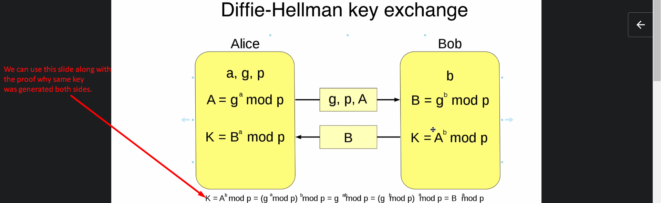
3. 